**Pie Chart Report**

1. **Task Description:**

Generate a Pie chart of product stocks available using matplotlib by taking input from csv file which contain two columns product name and stock.(atleast 10 rows required)

1. **Task Output ScreenShot:**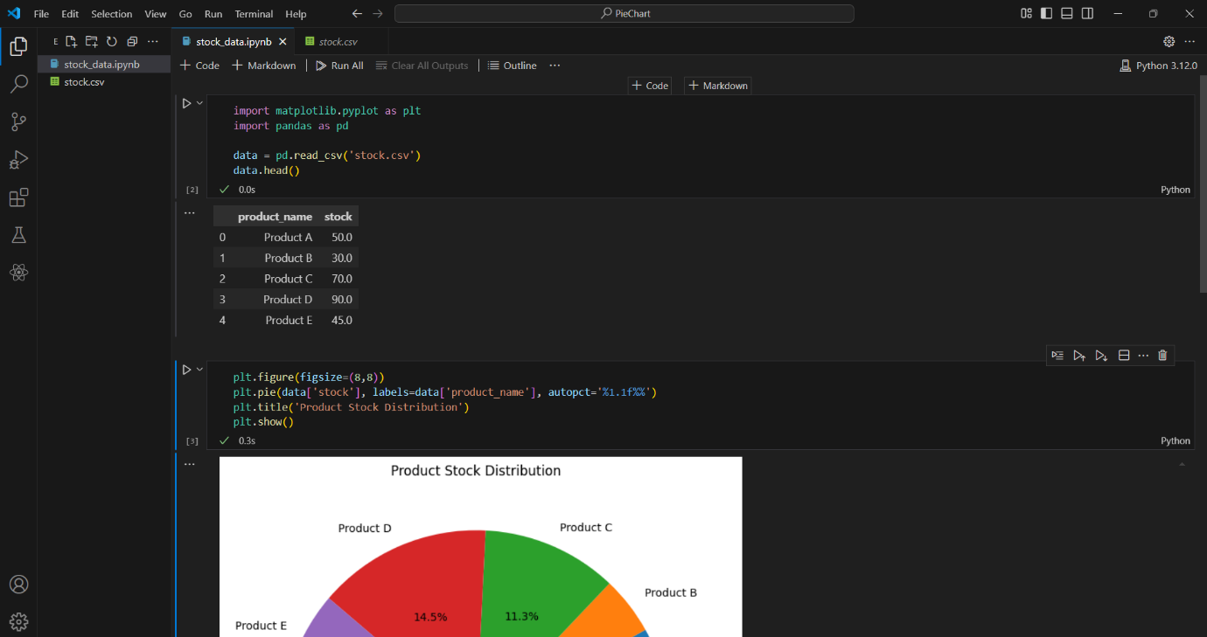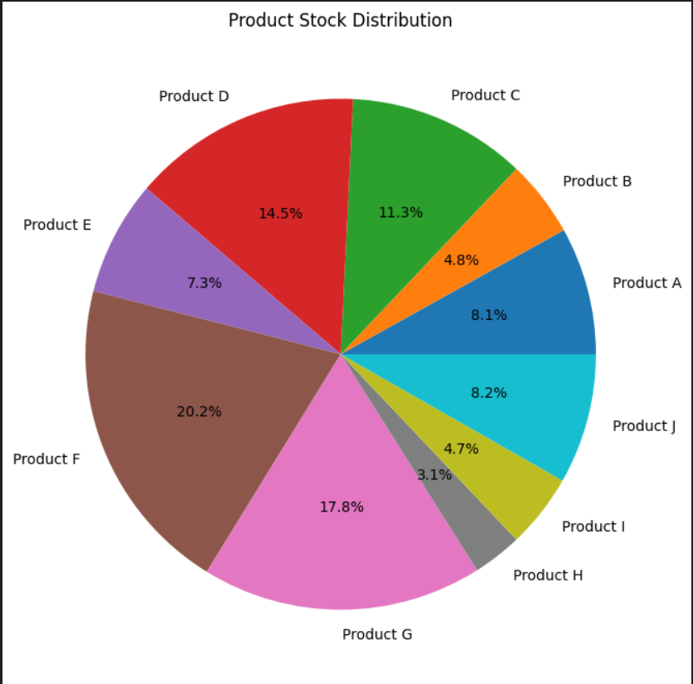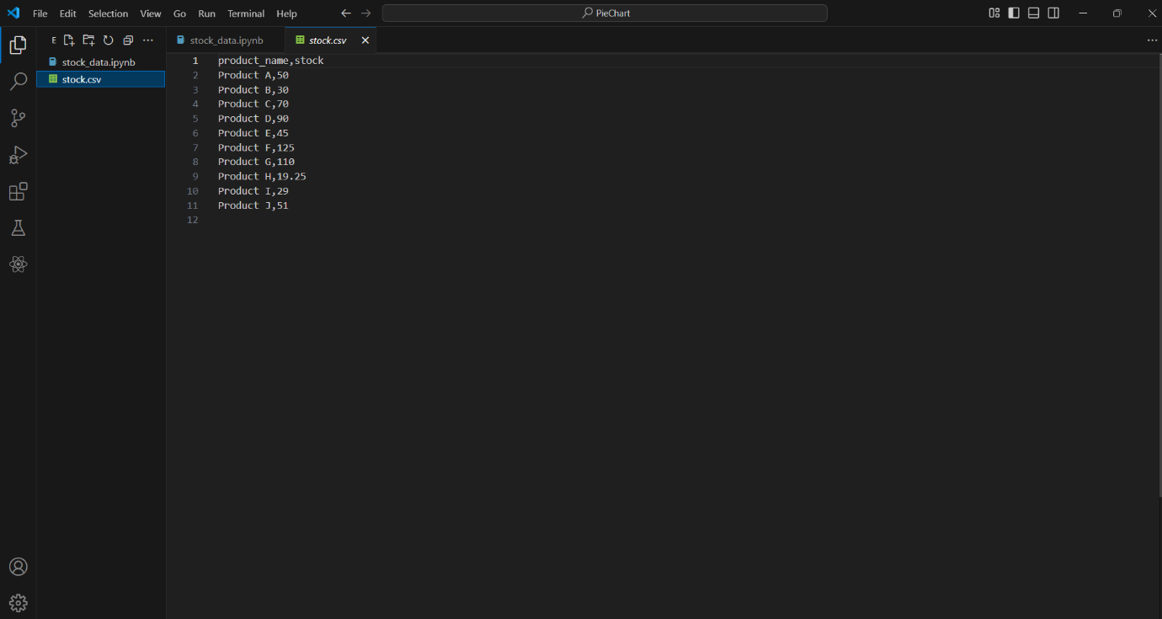
2. **Widget/Algorithm Used In Task**

* Matplotlib is used for plotting pie chart.
* Panda library is used to read the .csv file data.
* There is Stock.csv file which contains product name and stock price.
* And Pie Chart is represents how much percent does particular stock covers in the market on the basis of their price.